Where in your Studio does the PT 5201 fit?

The PT5201 sync generator is based on the Varitime™ concept featuring “infinite” timing over all lines and fields.
It is compact, half rack width unit, multistandard and fitted with three analog Black Burst outputs, one SDI output and two audio generators.
Additionally, the SDI generator feeds a converter giving an analog composite video output for test purposes.

The PT 5201 configuration is based on an well-arranged Windows interface.
The Windows interface makes it easy to manage all timing, patterns and audio features in one screen.
Modification from factory preset can be saved as a file on the PC harddisk or uploaded to the PT 5201 as a setup.
The setup is uploaded to PT 5201 in an instant mode or stored as a preset in the instrument.
Communication between PT 5201 and PC via standard RS-232 protocol makes it possible to use any kind of PC.
Status of current functions and systems will be displayed at any time, as matching LED’s on the PT 5201 front panel.
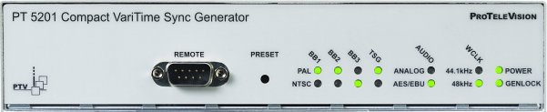
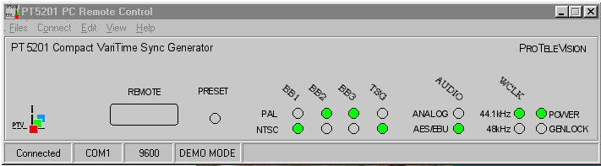

Analog Outputs
The sync generator is equipped with three VariTimeTM analog BlackBurst outputs. Each of these Black Burst outputs is individually fully timeable and can be configured as NTSC or PAL-generator in any combination.

Analog Test Signals Output
An analog Test Signal Generator, configurable in system and timing, is also included. The generator provides standard colorbars and test patterns according to SMPTE and EBU. Commonly used test signals are available for diagnostics in studio set-ups.

SDI Output
The SDI Generator output is based on the same digitally generated Analog Test Signal Generator and therefore it outputs the same test pattern and timing. The SDI output includes codes for embedded audio, featuring data for 1kHz Stereo and silence.

In general the SDI signals are generated as 10 bit signals, except one of the EBU 75% Color Bar Signal which is generated in 8 bit according to ITU 801

Analog Audio Outputs
The Analog Audio generator provides three different test tones in a number of levels. The output is available in stereo and mono and includes click markers for identification of left channel. The click interval is selectable.

AES/EBU Serial Digital Audio Outputs
The Serial Digital Audio Generator provides three different test tones in a number of levels. The output is available in stereo and mono and includes click markers for identification of left channel. The click interval and sampling frequency for the AES/EBU output is selectable. The generator also features system lock and timing facilities.

WordClock Output
The WordClock Signal is a continuous reference clock operating at TTL level, used for synchronizing audio equipment. Sampling frequency of 44.1 or 48 kHz is selectable in the audio window.

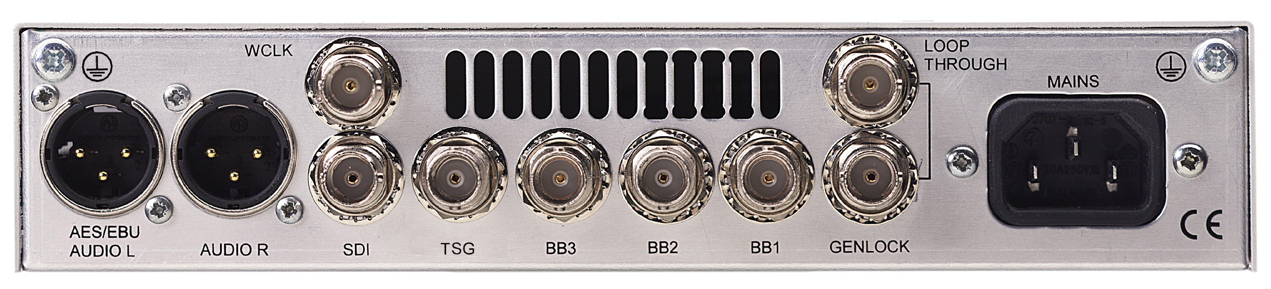

Master/Genlock Applications
The PT 5201 is designed to manage slave as well as master operations in various applications.

In systems where PT 5201 operates as a master, all timings are derived from an internal, high stability TCXO reference oscillator. When even higher stability is required, it can be locked to an external 10MHz reference, e.g. from a GPS receiver.

For use in applications where the PT 5201 operates as a slave, the genlock function features locking to Black Burst house sync and Composite Video signals, either in NTSC and PAL
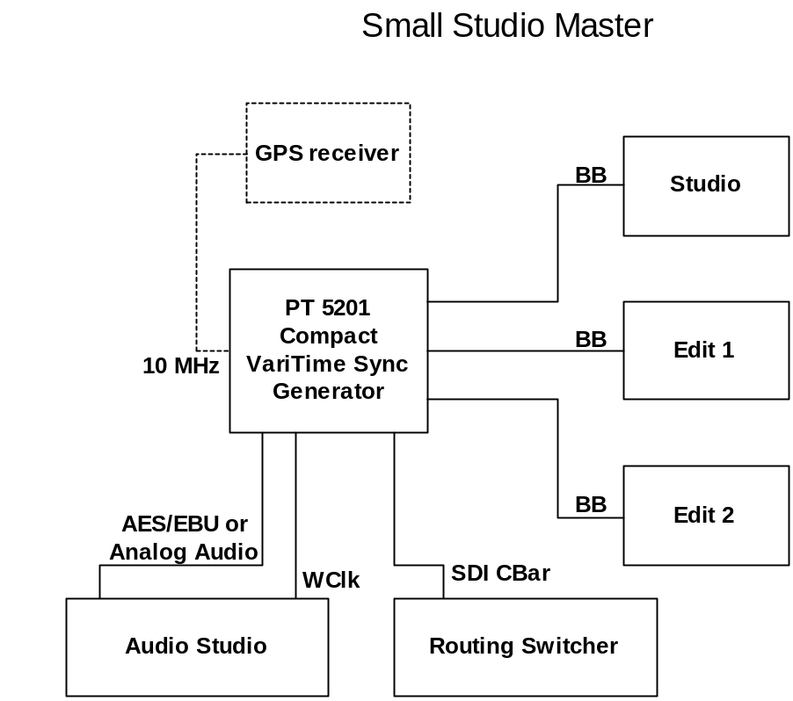The genlock function features passive loop-through, and has a common timing facility for the generator.

Example of PT5201 working as master generator in a regional studio

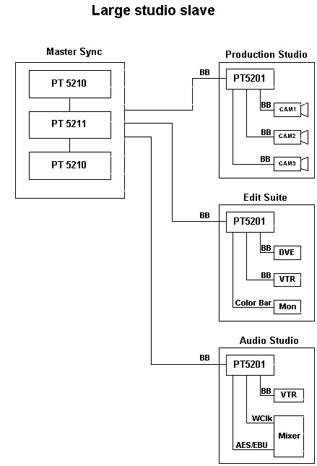

Example of PT5201 working as slave in a larger studio setup. Two PT5210 VariTime™ Digital Sync Generators along with a PT5211 VariTime™ Change Over Unit are suitable as master sync generator in large studio set-ups.

